**Project Design Phase**

**Problem – Solution Fit Template**

|  |  |
| --- | --- |
| Date | 25 June 2025 |
| Team ID | LTVIP2025TMID31802 |
| Project Name | Citizen AI |
| Maximum Marks | 2 Marks |

**Problem – Solution Fit :**

The Problem-Solution Fit simply means that you have found a problem with your customer and that the solution you have realized for it actually solves the customer’s problem. It helps entrepreneurs, marketers and corporate innovators identify behavioral patterns and recognize what would work and why

**Purpose:**

* Solve complex problems in a way that fits the state of your customers.
* Succeed faster and increase your solution adoption by tapping into existing mediums and channels of behavior.
* Sharpen your communication and marketing strategy with the right triggers and messaging.
* Increase touch-points with your company by finding the right problem-behavior fit and building trust by solving frequent annoyances, or urgent or costly problems.
* **Understand the existing situation in order to improve it for your target group.**

**Template:**

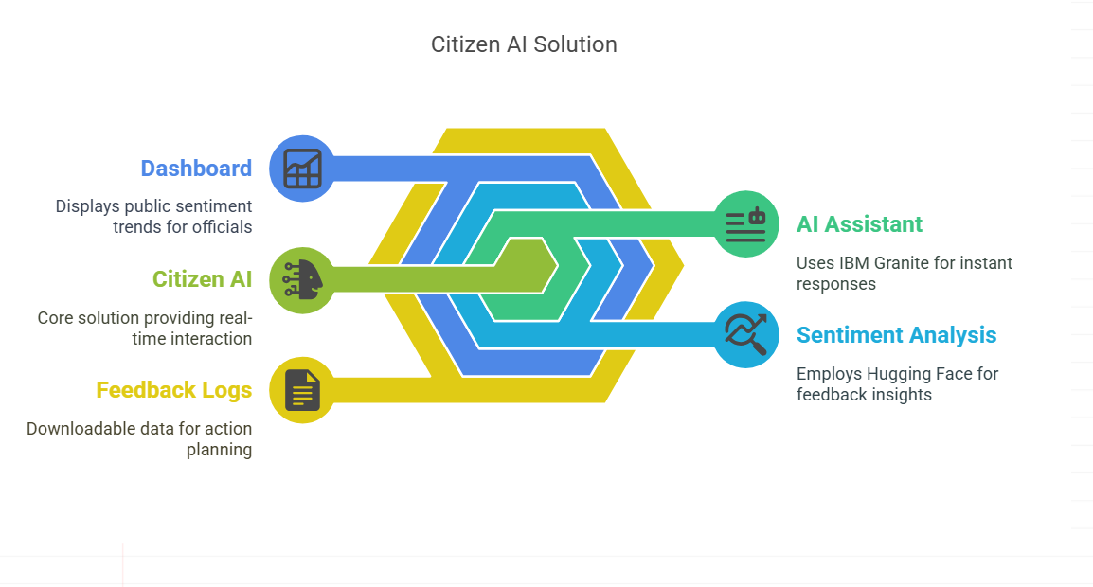

**1. Customer Segment(s)**

Urban and semi-urban citizens who need to interact with government services for documentation, grievances, and inquiries. Government officials monitoring public sentiment.

**2. Jobs-to-be-Done / Problems**

- Need to obtain reliable answers about government processes and services  
- Want to share feedback or complaints easily  
- Government needs insight into citizen sentiment trends

**3. Triggers**

- Long delays in service resolution  
- Frustration with outdated or slow government portals  
- Influence of digital governance campaigns or social media awareness

**4. Emotions: Before / After**

Before: Confused, ignored, frustrated  
After: Heard, informed, empowered

**5. Available Solutions**

- Government websites (often outdated, complex)  
- Help desks (require physical presence)  
- Social media (unstructured, lacks accountability)

**6. Customer Constraints**

- Limited digital literacy  
- Poor access to reliable internet  
- Distrust in response quality or follow-up

**7. Behaviour**

- Ask neighbors or use social media to inquire  
- Visit local government offices  
- Avoid giving feedback altogether

**8. Channels of Behaviour  
 8.1 ONLINE**

- Use mobile phones to access websites  
- Submit feedback via digital forms or apps

**8. Channels of Behaviour  
 8.2 OFFLINE**

- Visit municipal offices  
- Raise issues during local meetings or via postal applications

**9. Problem Root Cause**

- Government platforms are not designed for real-time interaction  
- Lack of tools for officials to capture and analyze structured feedback

**10. Your Solution**

Citizen AI provides:  
- Real-time AI assistant using IBM Granite  
- Sentiment analysis via Hugging Face  
- Dashboard for officials to view public sentiment in real time  
- Downloadable feedback logs for action planning